Prop 65 Changes to Labeling Effective August 30, 2018

All re-sellers of Simmons 800SB Series yard hydrants and 850SB repair kits must display the below warning on all printed advertising and internet sites.
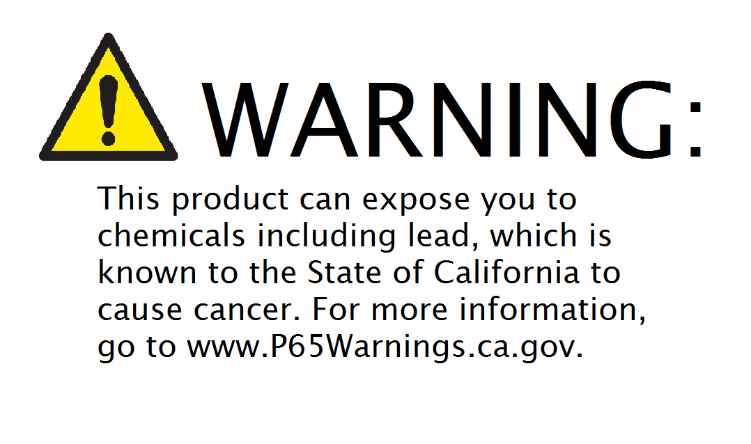
The Safe Drinking Water and Toxic Enforcement Act of 1986, better known as Proposition 65, requires businesses operating in the state of California to provide adequate warnings about exposure to, or the discharge of, chemicals that cause cancer or reproductive toxicity.
The changes to Proposition 65 on August 30, 2016:
- New labeling requirements that will include specific information about the prop 65 chemical(s) and the potential harm from exposure to that chemical.
- A warning symbol consisting of an equilateral triangle with a black outline present on the label.
- A link to the Prop 65 website where the consumer can learn more about the warning.
- The word “WARNING,” in all capital letters.

